L4-W5-DBS301-Group functions

*STEP 1: Put the SQL and the results after each question below*

*STEP 2: Submit on Blackboard.*

*Student Name: Abdul Rehman*

*Student ID: 149019176*

1 Display the difference between the Average pay and Lowest pay in the company.

Name this result *Real Amount*.

**Statement:**

select avg(salary)- min(salary) "Real Amount"

from employees;

**Output:**



2 Display the department number and Highest, Lowest and Average pay per each department. Name these results *High, Low* and *Avg.*

Sort the output so that the department with highest average salary is shown first.

**Statement:**

select department_id "Dep ID", max(salary) "High", min(salary) "Low", round(avg(salary),0) "Average"

from employees

group by department_id

order by 4 desc;

**Output:**

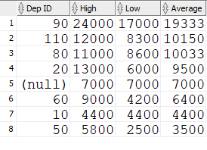

Rows: 8

3 Display how many people work the same job in the same department.

Name these results *Dept#, Job* and *How Many.*

Include only jobs that involve more than one person.

Sort the output so that jobs with the most people involved are shown first.

**Statement:**

select department_id "Dept#", job_id "Job", count(job_id) "How many"

from employees

group by department_id, job_id

having count(job_id) > 1

order by 3 desc;

**Output:**

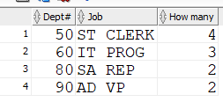

4 For each job title display the job title and total amount paid each month for this type of the job. Exclude titles *AD_PRES* and *AD_VP* and also include only jobs that require more than $15,000.

Sort the output so that top paid jobs are shown first.

**Statement:**

select job_id, sum(salary) "sum salary"

from employees

where job_id NOT IN('AD_PRES','AD_VP')

group by job_id

having sum(salary)>15000

order by 2 desc;

**Output:**

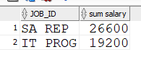

5 For each manager number display how many persons he / she supervises. Exclude managers with numbers 100, 101 and 102 and also include only those managers that supervise more than 2 persons.

Sort the output so that manager numbers with the most supervised persons are shown first.

**Statement:**

select manager_id, count(manager_id)

from employees

where manager_id NOT IN(100,101,102)

HAVING count(manager_id) >2

group by manager_id

order by 2 desc;

**Output:**

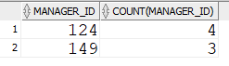

6 For each department show the latest and earliest hire date, BUT

- exclude departments 10 and 20

- also exclude those departments where the last person was hired in this century.

- Sort the output so that the most recent, meaning latest hire dates, are shown first.

**Statement:**

select department_id, MAX(hire_date) "Junior employees", min(hire_date) "Senior employees"

from employees

where department_id NOT IN (10,20)

AND hire_date<'00-01-01'

group by department_id

order by 2 desc;

**Output:**

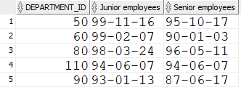

Rows: 5